Hotline Emergency Data Sheet: Partners of the Americas Data-sheet and instructions allows RSM to both support the individual at the point of an emergency, as well as activate your leadership team in a timely and effective manner to enable a broader crisis management response. The information provided in this data sheet will be held in confidence. There will be two forms of activation:
Emergency PHONE Notifications | Non-Emergency EMAIL Notifications
- Immediate threats to life from security incidents  - Serious injuries, assaults and hospitalizations  - Serious accidents, including where no injuries have occurred | - Minor injuries or illness which are not life-threatening  - Potential and upcoming risk periods  - Administrative incidents [lost/stolen passport, money and IT]
This service must be clearly defined within your team to avoid using the system for administrative purposes [missed flights, lost money and equipment, etc – which should be reported through the typical line management administrative process]. A staff message is provided in Appendix 1, which will assist you in advising staff members of what this service is designed for and how it can be activated. If problems occur then further RSM points of contact can be found in Appendix 2. An Activation Card is provided as a separate and printable document which staff can print and carry with them. This should be sent with the staff message and handed to new joiners during induction.
EMERGENCY PHONE NOTIFICATION POINTS OF CONTACT
RSM recommends three layers of emergency notification:
Primary Emergency Point of Contact
Name | Michael Moscarelli | Position | Chief Operating Officer
Location | Washington, DC | Email | Mmoscarelli@partners.net
Office Phone | +1 607-351-9724 | Mobile Phone | +1 607-351-9724
Skype |  | Other Options
Primary Emergency Point of Contact
Name | Natalie Abegesah | Position | Vice President of Human Resources
Location | Washington, DC | Email | nabegesah@partners.net
Office Phone | +1 240-480-6620 | Mobile Phone | +1 240-480-6620
Skype |  | Other Options
Secondary Emergency Point of Contact
Name | Carmen Pena | Position | Vice President of Programs
Location | Washington, DC | Email | cpena@partners.net
Office Phone | +1 571-296-0082 | Mobile Phone | +1 571-296-0082
Skype |  | Other Options
Tertiary Emergency Point of Contact
Name | Danielle Martin | Position | Director of Grants and Contracts
Location | Washington, DC | Email | dmartin@partners.net
Office Phone | +1 715-650-0246 | Mobile Phone | +1 715-650-0246
Skype | Daniellem133 | Other Options
EMAIL NOTIFICATION DISTRIBUTIONS
Insert other Individuals to be notified within the “TO” line on an email for emergency and non-emergency communications:
Michael Moscarelli – mmoscarelli@partners.net
Natalie Abegesah – nabegesah@partners.net
Danielle Martin – dmartin@partners.net
Carmen Pena – cpena@partners.net
Insert other Individuals to be notified within the “COPY” line on an email for emergency and non-emergency communications:
Debra Cooper – dcooper@partners.net
John McPhail – jmcphail@partners.net
TIME-SENSITIVE INSURANCE PROVIDER DETAILS
By providing insurance details, RSM can notify the affected individual of critical information that may enable a “self-help” response to an incident [such as activating medical insurance locally if injured or unwell]. Only insurance provisions that the individual must be aware of should be provided – allowing RSM to pass these details directly to the staff member. Where situations are serious, then RSM will activate the organization to alert them to the situation.
Medical Insurance Details
Insurance Carrier Name | AIG Travel Guard  GTP 0009158541-A | Coverages | Business Travel Accident Insurance
Policy Number | 9158541 | Website | aig.com/us/travelguardassistance
Phone Number | +1 240-864-9152 | Email | ShaerJN@ecsinsure.com
Client Manager | John Shaer | Email | assistance@aig.com
Please provide other time-sensitive insurance provider details [if applicable]:
Insurance Carrier Name |  | Coverages | General
Policy Number |  | Website
Phone Number |  | Email
Client Manager |  | Email
Insurance Carrier Name |  | Coverages | Dental
Policy Number |  | Website
Phone Number |  | Email
Insurance Carrier Name |  | Coverages | Vision
Policy Number |  | Website
Phone Number |  | Email
Client Manager |  | Email
Emergency Evacuation Carrier Name | AIG Travel Guard – see policy above | Coverage | Emergency Evacuation
Policy Number
Phone Number |  | Email
Appendix 1: Internal Staff Message

The following is a draft message that can be adjusted to better suit your team…

Dear Staff,
We have engaged Risk and Strategic Management [RSM] to support our ability to provide timely and effective emergency support to staff during work activities and work-related travel for safety and security incidents. RSM will provide an emergency hotline number (This number can be called from any location; international roaming must be activated) with a 24/7 call center service, which is attached to this email – you should print and carry a copy of this with you.
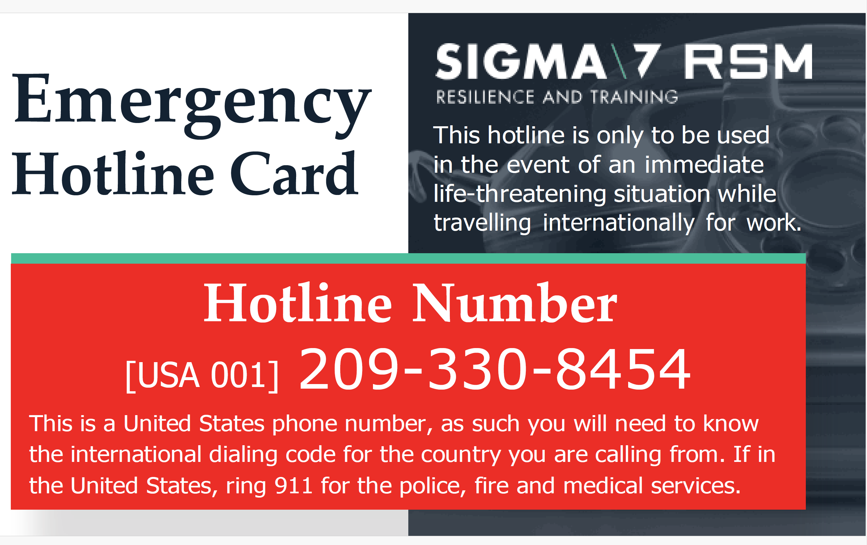
This service is only to be used for immediate and life-threatening situations, such as a natural disaster, if you have been seriously injured or require immediate hospitalization and need help if you have been involved in a serious accident if you have been robbed or assaulted, or during a civil disorder event or terrorist attack.
If you are arrested during work abroad and cannot get through to your manager, you can use this hotline to activate a response.
Please do not use this hotline for administrative purposes – such as if you lose your passport, miss your flight, or lose possessions. Such matters should be reported to your manager. Such matters should be reported through AIG Travel Guard at:
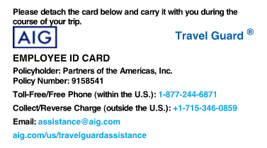

Upon calling the hotline number, you will be asked for specific details, including: 1] your name, 2] the name of our organization, 3] how best to contact you, 4] where you are, 5] what is happening, and 6] if you are at immediate risk.
Some basic immediate advice will be provided, and then a Risk Advisor from RSM will establish contact and offer more detailed advice. At the same time, the RSM Crisis Management Team will be activated to support you with the situation.
If you have any questions relating to this service please contact: Danielle Martin at dmartin@partners.net and Natalie Abegesah at nabegesah@partners.net.

If you have any questions relating to this service, please contact:
Appendix 2: RSM Contact Numbers
Area | Name | Title | Phone | Email
Service Admin/Immediate Support | Alan Rohn | Director Risk Consulting & Resilience | German Cell: +49 151 67970566  U.S. Cell +1 571 5602 389 | alan.rohn@rsmconsulting.us
General Advice | Jordan Young | Global security Director | U.S. Cell +1 571-486-6326  Office: +(1) 209-806-4859 | jordan.young@rsmconsulting.us
Finance and Contracts | Alex Bryan | Chief Financial Officer | U.S. Cell +1 571-284-9892 (US) | Alex.bryan@rsmconsulting.us
Quality of Service | Colin Brown | Chief Operating Officer | +44 (0) 7747 828382 (UK)  U.S. Cell +1 571-560-0010 | colin.brown@rsmconsulting.us

